**DAILY ONLINE ACTIVITIES SUMMARY**

|  |  |  |  |  |  |  |  |  |
| --- | --- | --- | --- | --- | --- | --- | --- | --- |
| **Date:** | **17-06-2020** | | | | | **Name:** | **Sannidhi P** | |
| **Sem & Sec** | **8th sem B sec** | | | | | **USN:** | **4AL16CS084** | |
| **Online Test Summary** | | | | | | | | |
| **Subject** | | **-** | | | | | | |
| **Max. Marks** | | **-** | | **Score** | | | **-** | |
| **Certification Course Summary** | | | | | | | | |
| **Course** | **SOLOLEARN** | | | | | | | |
| **Certificate Provider** | | | **JAVASCRIPT Tutorial** | | **Duration** | | | **2hrs** |
| **Coding Challenges** | | | | | | | | |
| **Problem Statement-** : **\*c program for triply linked list** | | | | | | | | |
| **Status: completed** | | | | | | | | |
| **Uploaded the report in Github** | | | | | **yes** | | | |
| **If yes Repository name** | | | | | **Sannidhi1** | | | |
| **Uploaded the report in slack** | | | | | **yes** | | | |

Online Test Details: (Attach the snapshot and briefly write the report for the same)

Certification Course Details: (Attach the snapshot and briefly write the report for the same) 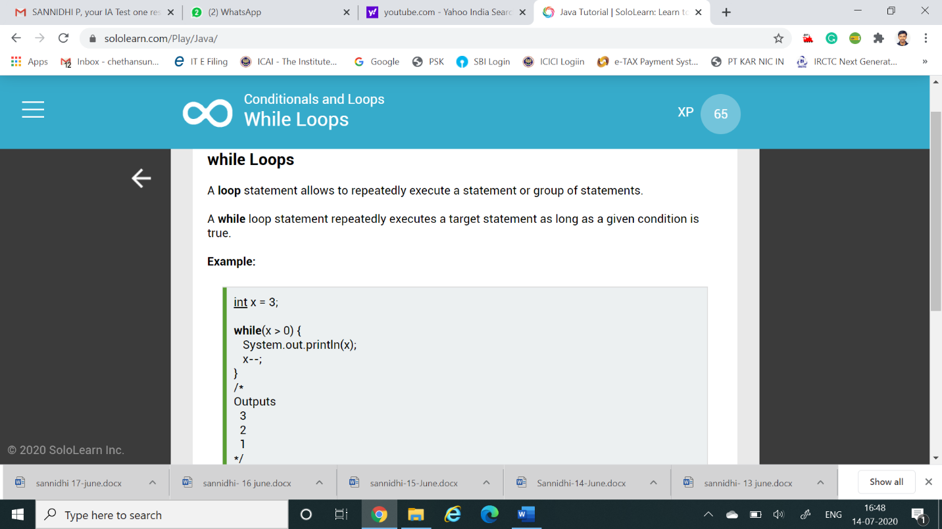

Saw videos on java programming

Coding Challenges Details: (Attach the snapshot and briefly write the report for the same)

Coding was given and it was uploaded for github and slack

#include<stdio.h>

struct SLL;

struct TLL {

struct TLL *top;

struct TLL *bottom;

struct SLL *next;

};

typedef struct TLL tnode;

typedef struct SLL {

char ch;

struct SLL *link;

};

typedef struct SLL snode;

snode *newnode, *ptr, *prev, *temp;

snode *first = NULL, *last = NULL;

tnode *newt, *tlast = NULL, *ttemp;

//--- TLL node---

tnode* create_tnode()

{

    newt = (tnode *)malloc(sizeof(tnode));

    if (newt == NULL)

    {

        printf("\nMemory was not allocated");

        return 0;

    }

    else

    {

        newt->top = NULL;

        newt->bottom = NULL;

        newt->next = NULL;

        return newt;

    }

}

//---SLL---

snode* create_node(char c)

{

    newnode = (snode *)malloc(sizeof(snode));

    if (newnode == NULL)

    {

        printf("\nMemory was not allocated");

        return 0;

    }

    else

    {

        newnode->ch = c;

        newnode->link = NULL;

        return newnode;

    }

}

//--- insert SLL---

void insert_node_first(char c)

{

    newnode = create_node(c);

    if(tlast->next == NULL)

        tlast->next = newnode;

    if (first == last && first == NULL)

    {

        first = last = newnode;

        first->link = NULL;

        last->link = NULL;

    }

    else

    {

        temp = first;

        first = newnode;

        first->link = temp;

    }

    printf("\n----INSERTED %c TO SLL----", c);

}

//---insert TLL---

void insert_Tnode()

{

    newt = create_tnode();

    if (tlast == NULL)

    {

        tlast = newt;

        tlast->next = NULL;

        tlast->top = NULL;

        tlast->bottom = NULL;

    }

    else

    {

        ttemp = tlast;

        tlast = newt;

        tlast->next = NULL;

        tlast->top = ttemp;

        tlast->bottom = NULL;

        ttemp->bottom = tlast;

    }

    printf("\n----CREATED NEW TLL----");

}

void main()

{

    char s[100], n;

    int i;

    scanf("%[^;]s",s);

    insert_Tnode();

    for(i = 0; s[i] != '\0'; i++)

    {

        n = s[i];

        if(n == '\n')

            insert_Tnode();

        else

            insert_node_first(n);

    }

    printf("\n%s\n",s);

}